Tuesday 2nd June 2020

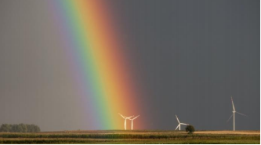
Have you ever seen a rainbow? Do you know where rainbows come from?

★ Talk to someone at home about rainbows. You could talk about:
The colours that you can see (can you always see all of the colours like in the picture above?)
The shape of the rainbow (is it always an arc shape?)
What is the weather like when you see a rainbow?
And talk about this: (guess if you don’t know)
How are rainbows formed?
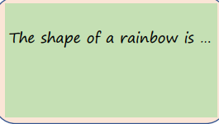
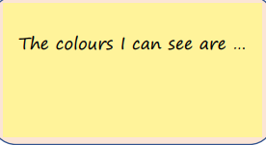
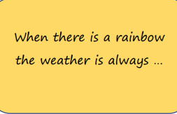
Write down your ideas here:

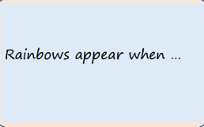

Read this piece of explanation with someone at home to find out about rainbows: You can listen to an audio version of the text below here:
https://soundcloud.com/talkforwriting/rainbows/s-Mt28P9OJlXO

Rainbows
A rainbow is an arc of colour in the sky that can be seen when the sun comes out during or after a rainstorm. How a rainbow is formed A rainbow is formed when a person sees the sun or a light source shining through rain drops.
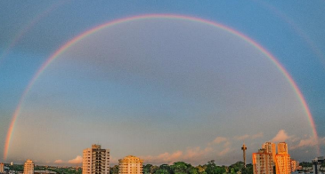

This type of rainbow is formed when sunlight strikes raindrops, at a forty-two-degree angle, in front of the people looking at it.
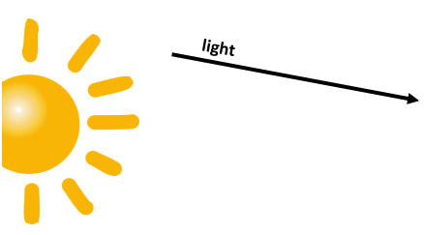

When the light strikes the drops, it changes and splits into colours, called a spectrum. These colours are bounced back to us so that we see a rainbow.
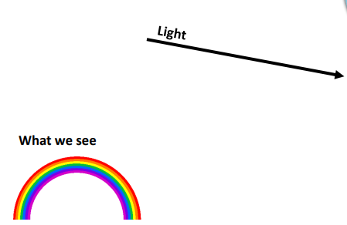
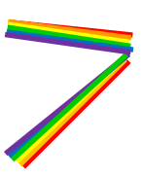

The colours of a rainbow are red, orange, yellow, green, blue, indigo and violet.

