Wednesday 3rd June 2020
Where are rainbows? The rainbow is an optical illusion which means that it tricks your eyes so that what you think you see is different from what is really there. Rainbows are not in a fixed spot in the sky as the appearance of a rainbow depends on where the person seeing it is and where the light is. Rainbows are actually full circles but viewers on the ground can only see them above the horizon.
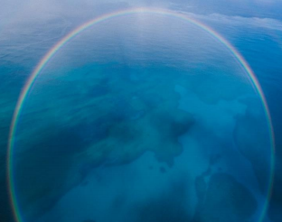

Fascinating fact!
A moonbow, also called a lunar rainbow, is a rainbow that is produced by light from the moon!
Glossary (what the words mean)
arc
A part of a line that forms the outside of a circle.
light source
The place or thing which you get light from.
horizon
The line in the far distance where the sky seems to meet the land or the sea.
spectrum
The range of different colours that you get when light passes through a glass prism or through a drop of water.

Now that you have read the information explaining about rainbows look again at the sticky notes you wrote on before. What have you learnt about rainbows? Fill in these sticky notes:
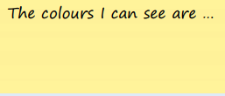
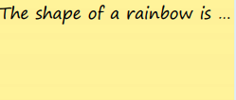

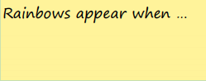
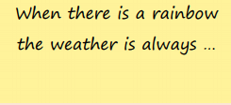

Vocabulary challenge
★ Read the glossary and check that you understand the definitions
★ See if you can do these mini-challenges:
1. Use the text to help you to write your own definition of optical illusion
2. Draw an arc

3. Write down or draw as many light sources that you can think of:

4. Using Google, search for a picture of a rainbow. Can you see the horizon in the picture? Show someone at home where the horizon is. Can you explain what it means?

