Thursday 4th June 2020
Reading Challenge
Rainbows
A rainbow is an arc of colour in the sky that can be seen when the sun comes out during or after a rainstorm. How a rainbow is formed A rainbow is formed when a person sees the sun or a light source shining through rain drops.
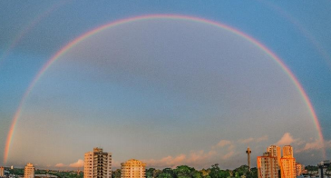

This type of rainbow is formed when sunlight strikes raindrops, at a forty-two-degree angle, in front of the people looking at it.
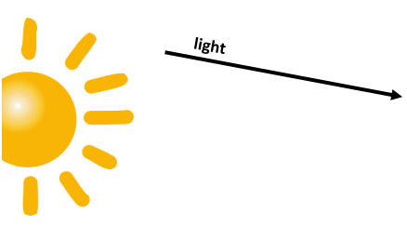


When the light strikes the drops, it changes and splits into colours, called a spectrum. These colours are bounced back to us so that we see a rainbow.
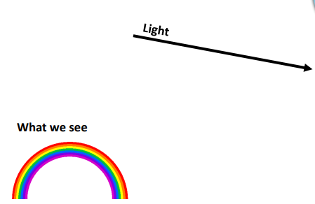
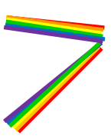

The colours of a rainbow are red, orange, yellow, green, blue, indigo and violet.

The text you have just read is an explanation text. It gives us facts about a topic and explains the causes of things. Most information texts have:
A title ❒
An opening sentence that says what the text is about ❒
A series of facts explaining why something happens ❒
Pictures and or diagrams ❒
Read the rainbow explanation text again and see if you can spot each of the items listed above. Tick the box when you find them.

EXTRA READING CHALLENGE
If you have any information or explanation books at home, or you are able to use a computer you could look at one of these websites:
https://www.natgeokids.com/uk/category/discover/
https://www.dkfindout.com/uk/
Use your scanning skills (read over the text quickly to find something) and see if you can find each of these in one book or on one webpage about something you are interested in:
✓ A title
✓ An opening sentence that says what the text is about
✓ Facts (information or explanation about something)
✓ Fascinating fact
✓ A glossary
✓ Photographs or diagrams
Write down what you have found

