Monday
- Work out the following problems and show your workings:
- Bob had 7.34 metres of string. He wanted to share this equally between 10 of his friends to make shoelaces. How many centimetres of string would each of his friends have?

- Tilly used to run 3.28 km a day until she was 30 years old. She then started to run 736 metres less each day. How many metres does she now run each day?

- Malc’s shed door was 3.72 metres tall and 92 cm wide. He wanted to buy some wood to make a frame around the door but the wood is measured in millimetres. What would these measurements be in millimetres?

- Andy wanted to measure the lengths of different animals. He recorded a lynx as 3.87m, an elephant as 194cm and a viper as 4582mm. A room in the zoo was 0.23km wide, would the animals be able to stand in a line behind each other in this room?

- A piece of wood is 1.49m long. Joe cuts off 59mm from one end and then Bill cuts off 28.2 cm from the other end. How much is left in cm and mm?
Tuesday
https://classroom.thenational.academy/lessons/to-apply-measures-and-conversions-in-context/activities/2
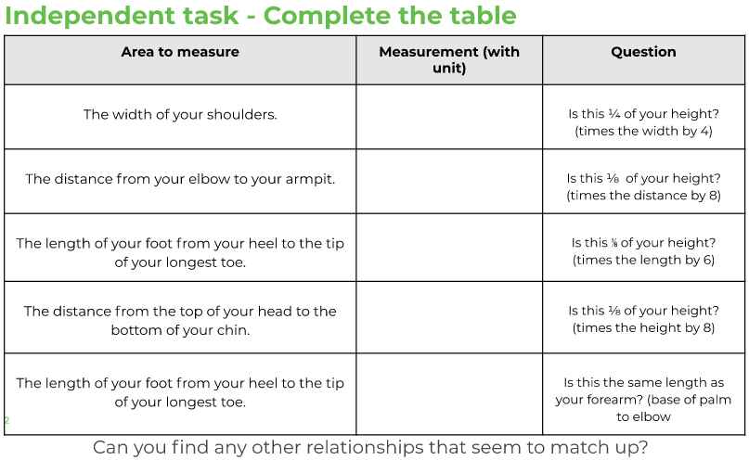

Wednesday
https://classroom.thenational.academy/lessons/to-convert-between-pounds-and-kilograms/activities/2
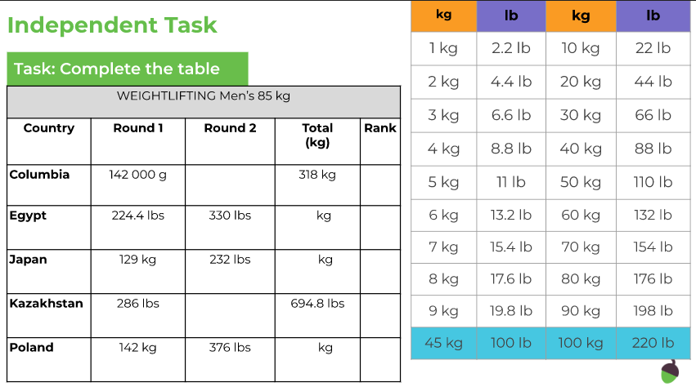

Thursday
Can you solve these word problems using multiplication?
Select the most appropriate method for the numbers involved.
- If I need 5 pencils for each child in a class of 28 pupils, how many pencils will I have? How many pencils will I need for 6 classes of 28 pupils?

- Helen ran 15.67 miles every day. How many miles did she run after 100 days?

- My sister and I go on a shopping spree. She buys 3 pairs of shoes at £26 each and 2 tops at £12 each. I spend 4 times as much. How much do I spend?

- In a concert car park, there are 4 full buses which can hold 76 passengers. Six more full buses turn up. How many people are at the concert?

- A group of 14 children go on a school trip. The trip costs £14 each. They also need £7 spending money each. How much will the 14 children need in total?

- One ladybird has 24 spots. How many spots do 327 ladybirds have?

