29
28
27
26
25
24
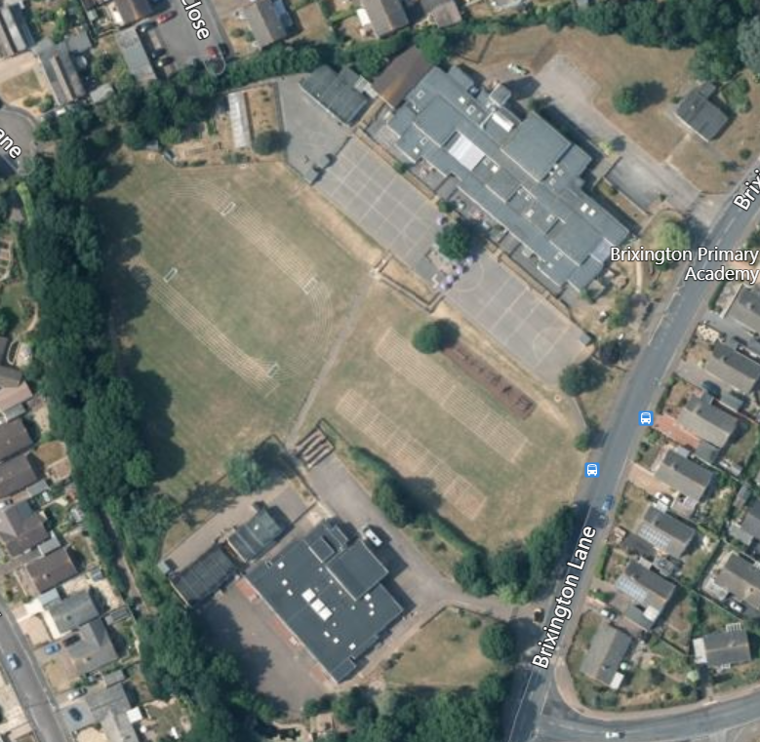
13 14 15 16 17

The greenhouse in the farm is at 146 283
Your Task:
Find as many locations as you can, identify what they are and write down their 6-figure grid references.

