DESIGN TECHNOLOGY WORK AT Home Learning Time
BACKGROUND INFORMATION, PLEASE READ CAREFULLY.

The Old Stone Age people were hunter-gatherers who lived by hunting animals and collecting fruit and nuts
The earliest human shelters were natural caves or rock shelters. People also made huts and shelters from wooden frames, or frames made from animal bones, and covered them with animal hides. During the Mesolitic period, huts became more advanced. Huts were thatched with reeds, mud and turf. By the Neolithic period, people were making more permanent homes from wattle and daub. This involved weaving sticks or reeds around a structure, then filling the gaps with a mix of soil, clay or animal dung.

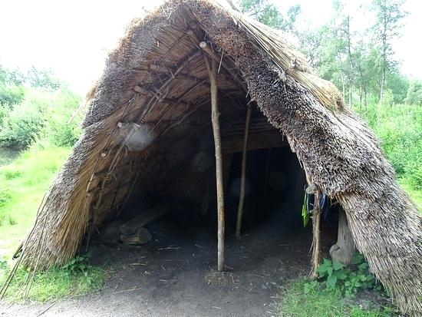

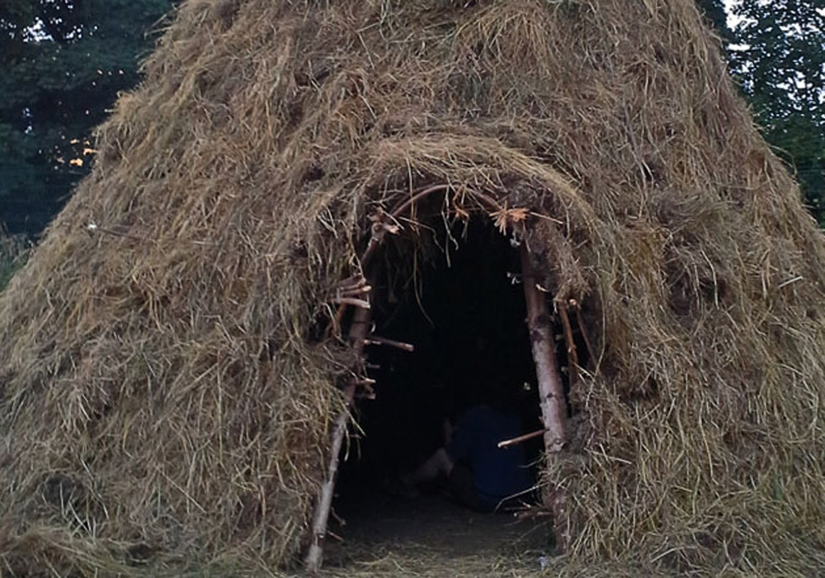

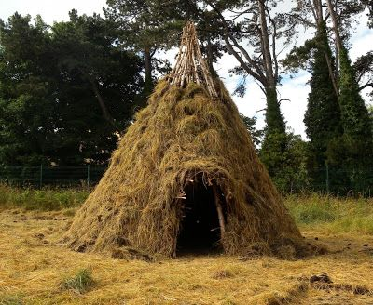
Tasks for Now:
- Research Stone Age to Iron Age houses/ dens
- Draw and sketch some of your own designs
- Optional: Make a collage of images you collect from Internet based research

