FUN Home Activities Year 3
 Build a den!
Make vegetable prints!
Paint some flowers in a vase!
- Build a Lego Model!
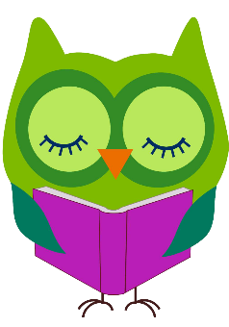 Design a house/ a palace using MindCraft programme.

