Year 3 Home Learning-WB 01.06.20
WELCOME BACK 3B AND 3K TO THE SECOND HALF OF THE SUMMER TERM. WE HOPE YOU ENJOYED YOUR HALF TERM BREAK AND ENJOYED LOTS OF TIME IN THE SUNSHINE AND CONTINUED TO STAY SAFE.
Our key priorities for learning this week:
- Maths- Capacity
- English- Write a traditional tale with a twist.
- Reading- Reading comprehension worksheets + Oxford Owl
  English-please complete every day:  Writing: Write your own story using a traditional tale that you know. We would like you to add a twist to the story to slightly adapt either the title, characters or content. The pattern of the story will be the same.  Reading: Reading comprehension sheets + oxford owl  And  Independent reading  Words of the week:  Victory, nifty, sneakily, dribble, deliberately |  | Maths-please complete every day:  Choose from…….  Using a measuring jug at home to find 100ml, 200ml, 500ml and 1l. Can you find 150, 250, 250 etc…..  - TT rockstars  - classroom secrets  - My Maths  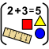
Choose at least one activity per day from the list below

Science  Cut ice cubes in half like magic!    See website for instructions….. | Music    Use the PowerPoint to learn the National Anthem off by heart. If you already know the anthem, then put the anthem into a colourful poster that could be displayed around our school. |  | PSHE  Follow the June calander for wellbeing. Can you complete the task each day.  Or    Do the mindfullness colouring pages to give yourself some down time. If you don’t have a printer why don’t you try and create your own mindfullness colouring page?
PE  It’s the Summer term so let’s practice for sports day as this is what we would be doing if we were in school.  So let’s start with sprinting practice……    Practice running in your garden. Can you try each day to beat your time? Write down your times each day. I would like your time to improve so that I can clearly see an improved stamina throughout the week. | Geography  Find a mountainous region in the world eg The Alps, The Andes, The Pyrenees and make a fact file with drawing and key information. |  | Art  We would like you to collect things from around your garden or on a nature walk/day out and create your own art work.  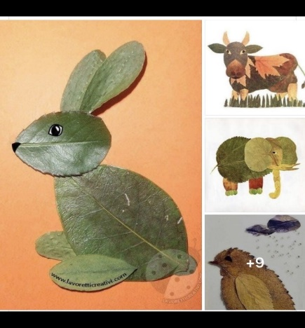  

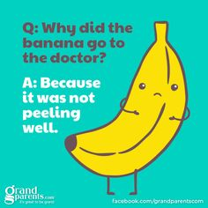
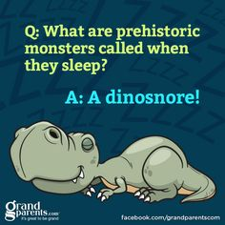
We miss you all so much!!!
Miss Brown, Mrs Keilty & Mrs Cameron



