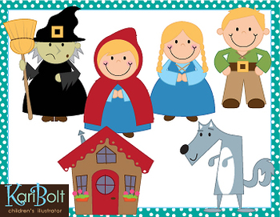
Wb 01.06.20
Story telling week!
It’s time to plan, create, write and perform your own story.
Miss Brown and Mrs Keilty would like you to take a traditional tale of your choice: Little Red Riding Hood, Cinderella, Rapunzel etc… and re-write the story with a twist (we had a go at this in school in February but we would like you try have another go with a different story to the one you used before!)
You can plan your story using the frame
on the website (make sure your story has a problem which is then resolved)
We would like you to use lots of imagination and create a story that you are proud of….
You can then have a go at presenting your story (a bit like you would in class at the front). Video and send to us, perform in front of your family, perform to your pet.

