Tuesday 5th January 2021
Afternoon learning activity: New Year Resolutions
- Following on from Mr Dyer’s Assembly on Resolutions, talk to your child about ideas they may have for things they would like to improve, learn or experience this year.
Complete the sheet below (or if no printer record on paper) with ideas for home and school resolutions.

- Now Boggle time!!
How many words can you make out of…

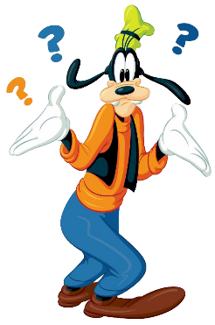
new year resolutions




