Maths Challenge!! Thursday 7th January
Before you do your Maths today I have a challenge for you ………should you wish to accept it!!!
It will really help you to have some actual tens and ones to help you calculate. Can you make some bundles of ten and ones using some of the ideas below? You might come up with an even better more exciting way – make sure you take a photo!
You can then use these practically to help you build and partition numbers for your maths work over the next few weeks….. and beyond! It would also help if you could draw a tens and ones chart on a big piece of paper where you can lay out your numbers
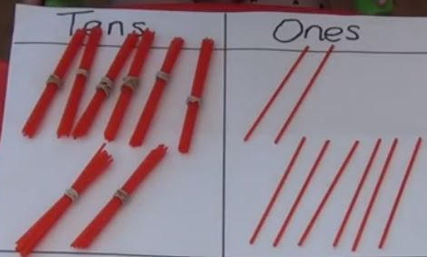
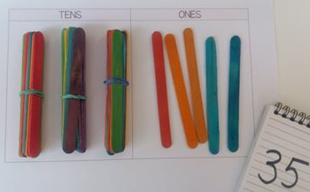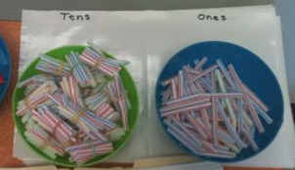
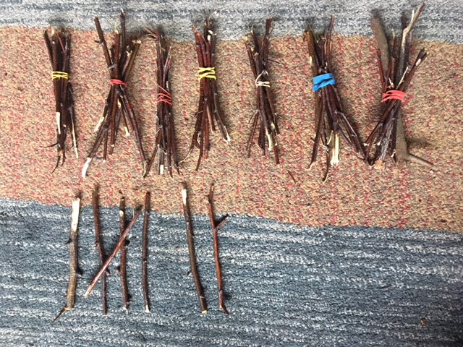
What other way of grouping/ counting is used here? What two, 2-digit numbers are the straws showing here?
What would the total be?

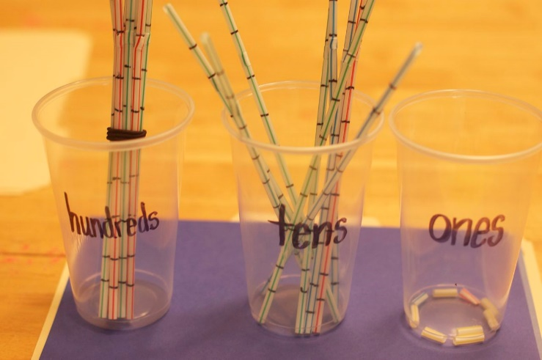
If you need a challenge have a go at making
hundreds tens and ones!!

