Year 2 Home Learning Week 2 : 11-15.01.21
Here we go with another week of home learning for all our Year 2 superstars! We have been really impressed with all the fantastic learning that has been going on at home – thank you children for working hard and thank you adults for your help and support with this – you are all doing a great job!
Monday 11th Jan
Maths: Hopefully you will have seen an extra video that I uploaded this weekend with some support for our maths work. If you have not yet watched this, please do before starting today’s activity as it will help reinforce the work covered so far. https://www.youtube.com/watch?v=DVNhLJ_FiR0&feature=youtu.be
No loom today! -Warm up – place value/ number powerpoint (website)
Then look at the sheet below and complete the word problems to consolidate our skills of adding two,2-digit numbers. Show your workings using the different representations we covered last week.(extension challenge on website)
English:
https://www.loom.com/share/ccff9e4c00764acfbb6c17e1db961ad4

Phonics – continuing our focus on prefixes
- Explanation of prefixes and suffixes https://www.bbc.co.uk/teach/class-clips-video/english-ks2-wonderful-words-prefixes/zknd7nb
- Prefix ‘mis’- no sound with this one (sorry for the American spelling of favourable!) https://www.youtube.com/watch?v=x6xHyKmRuhY After watching this can you write down all the ‘mis’ words that you saw?
- We have looked at ‘un’ dis and ‘mis’ prefixes so far. Can you write out these words using the correct prefix (or print and complete the table if
you prefer)

Science: - This term we will be learning about ‘Living things and their habitats’. As with the history task last week, we will start this unit of learning by finding out what the children already know from their own general knowledge or prior learning. Please help your child to read the questions on the attached sheet (below) and allow them to show their ideas/ knowledge through written or drawn ideas. For some sections you may need to scribe their ideas. It doesn’t ,matter if they don’t know many answers or have many ideas we just want to see where they are starting from.
P.E - from Mrs Clarke - Lesson 1 dribbling the ball
https://www.loom.com/share/a6d22f6ab0404102926724b8a475cf6b

Maths:
LO: Add two,2-digit numbers by partitioning 11.01.21

Miss Andrews has 36 sweets. Mrs Gerry has 27 sweets. How many sweets do they have in total?

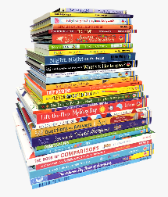

Mrs Nettleton has 18 books. She bought 25 new books for Christmas. How many books does she have now?

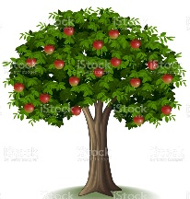
Mr Dave planted an apple tree. It was 36cm high. It has grown 17cm. How tall is the tree now?

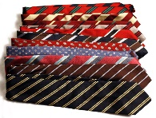
Mr Dyer had 48 ties. He received 18 more for Christmas. How many ties does Mr Dyer have now?

Extension challenge: add 3, 2-digit number word problems (see website)

Phonics
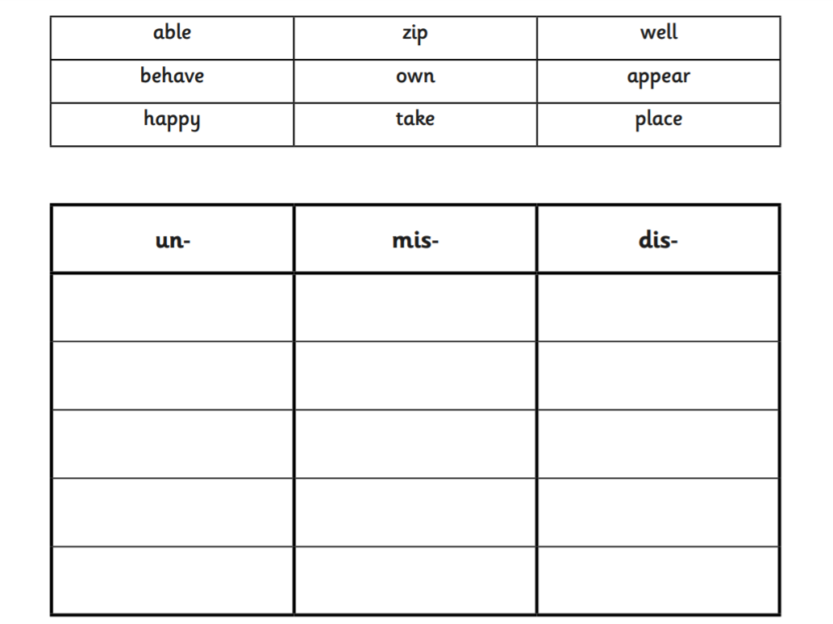

Science
What does ‘living’ mean?

List /draw some living things:
What does ‘non-living’ mean? Can you list /draw some non-living things?
What would you like to find out/learn about living things? Questions?
What do you think these words mean?

habitat –

mammal –

amphibian –

reptile –

fish -

WEEK 2 ASSEMBLIES:
https://www.brixington.devon.sch.uk/assemblies-and-whole-school-challenges/

