Year 2 Home Learning Week 2 : 11-15.01.21
Tuesday 12^{tth} Jan
Maths: Subtraction with 2, 2-digit numbers
https://www.loom.com/share/fd19255bb7714b9fbb2a532b858b9e5c
After watching the link have-a-go at these subtractions- partition/show and calculate with your tens and ones apparatus and then show on a number line. Do the set A questions and if you feel confident try set B!
A 36 – 21 = 39 – 16 = 42 – 21 = 54 – 32 =
B 46 – 24 = 77 – 15 = 69 – 27 = 84 – 56 =

English – Instructions
https://www.loom.com/share/dd954d93706543e1bae73886889314ac
See website for reading comprehension activity

Phonics
https://www.bbc.co.uk/teach/class-clips-video/english-ks2-wonderful-words-prefixes/zknd7nb
Prefix/suffix song https://www.youtube.com/watch?v=H2Z4p0au1yk
Activity: Look at the prefix/suffix sheets (website). Can you think of any other words which are examples of the given prefixes/suffixes? List your ideas.
Extension: Can you write some interesting sentences using these words?

DT
In our DT this term we are thinking about foods/healthy eating- planning and making a recipe.
For this first lesson we are finding out about the different food groups and the Eatwell healthy plate guide.
First look at the ‘Tesco Eat Happy’ link below
https://www.youtube.com/channel/UCiGAAbnpbIYqZeCFeA4K_nQ
If you scroll down, click on the Healthy eating video -watch and discuss the foods the children see. (If you wish to you can watch the other videos on the different food groups listed alongside also!)
Now look at the following explaining the Eatwell Healthy plate
- https://www.youtube.com/watch?v=CSOtIfh82Ns&feature=emb_title
- Healthy eating powerpoint on website
Activity: Look at the food pictures below. Can you work out which food group they belong to?
Can you draw/ cut and stick/ list (whichever’s easiest for you!) the foods against the part of the plate they belong in? (attached on website too)
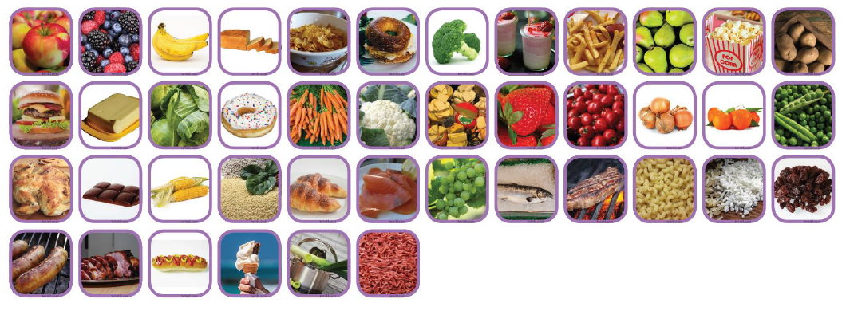
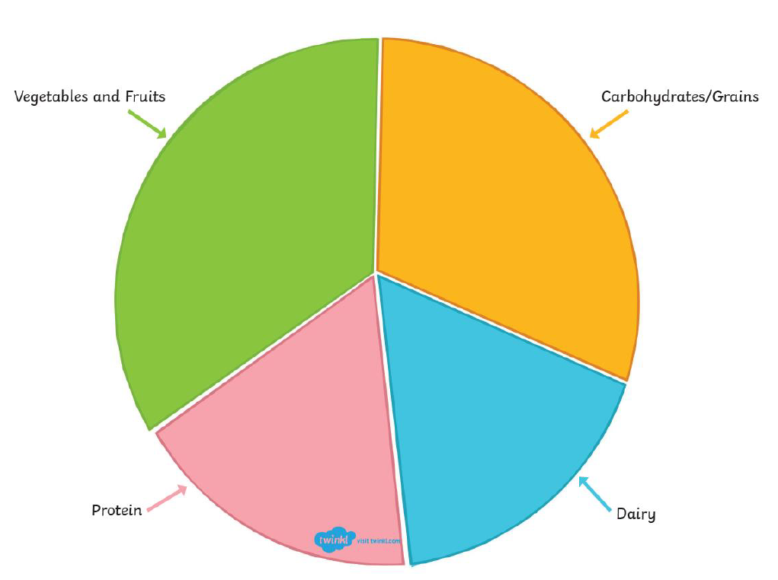

RE: What is it like to be a Muslim https://www.loom.com/share/b68441b05be3435484c21f868c43a809

