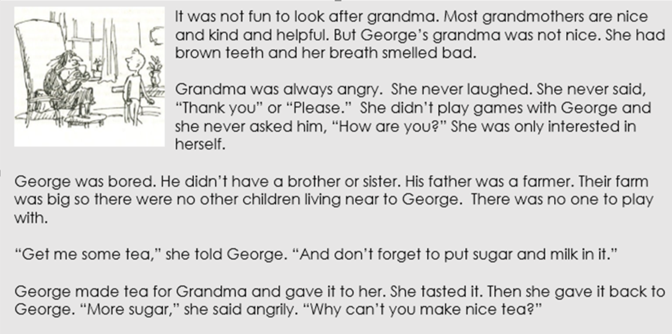

- Does George like looking after his grandma? Why?
- Which word describes grandma’s teeth?
- Is grandma a polite person? How do you know?
- What is grandma interested in?
- Why was George bored?
- Why are there no children around to play with George?
- What is the farm like?
- Which word tells you that Grandma is not happy with her tea?
- How do you think George feels about looking after grandma?
- Why was the tea not good enough for grandma?

