RE home learning week beginning 6th July
Focus: Ceremonies that mark milestones in life.
Roman Catholic First Communion:
Watch the BBC clip
https://www.bbc.co.uk/teach/class-clips-video/religious-studies-ks2-holy-communion/z7xhy9q
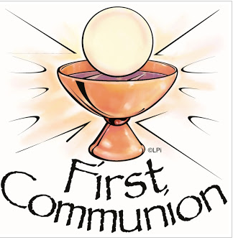
Look at the prayer that is said at the end of the Holy Communion. Copy it out, in your loveliest handwriting and fill in the missing words. Decorate the prayer if you wish.


