Design and Technology – Where does our food come from?
Over the last few weeks, we have been thinking about seasonal food. However, not all food grows locally, and certainly not all year round, so where does our food come from?
Task:
Choose a meal you enjoy eating. Identify all the different ingredients needed for that meal. Here is an example for spaghetti Bolognese. 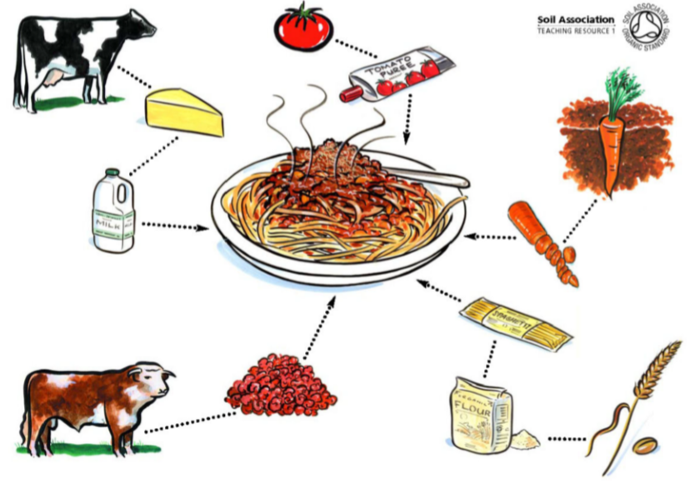
Next, research to find out where each of these foods comes from and add this information to your picture / diagram.

Extra Challenge:
What are food miles? Why might someone want to keep their food miles as low as possible?

