Year 3 Home Learning-WB 04.05.20
Our key priorities for learning this week:
- Maths- to revise key maths skills in revision booklet.
- English- to understand and use key grammar skills (adjectives and adverbs)
Challenge- I can independently use these grammar skills in a sentence
- Reading- Reading comprehension for fiction, non-fiction and poetry or reading with an adult/sibling once per day.
  English-please complete every day:  Writing: Talk for writing scheme-see document on the website to help you follow day by day instructions.  Reading: Follow the activities for Monday-Wednesday. Thursday and Friday read for pleasure (something you enjoy) in an unusual place.  Words of the week:  Corridor, grasshopper, emerge, commotion, knock |  | 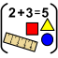  Maths-please complete every day:  Choose from…….  - Maths home learning booklet (do a few pages a day to revise key facts)  - TT rockstars  - Classroom secrets
Choose at least one activity per day from the list below

Science    Folow the instructions on the school wesbite. Can you make an egg float? | Music  https://www.bbc.co.uk/bitesize/topics/zcbkcj6/articles/z2mqw6f    Look at this website to learn all about pulse and rhythm. Then try to listen to your favourite song and can you find the pulse and rhythm in that song? |  | PSHE  Mrs Keilty and Miss Brown would like you to choose 1-day next week for a ‘mind and wellbeing’ day. A day to look after yourself and your family. You could use the yoga cards, mindfulness activity cards, mindfulness colouring, listening to music, some time for peaceful and reflection in a quiet place…….  
PE    Use the activity cards on the website to practice a new P.E. skill a day. Then have a go at using all of the cards to set up your very own circuit. Try and get your whole family involved. Year 3 – You are the P.E. teacher so you must set up the activities independently. | History    Friday 8th May is VE day. We would like you to plan a picnic to have with your family. We would also like you to make red, white and blue bunting to put in your windows at home. You could even do some research about why we are celebrating this day. |  | Computing  https://www.bbc.co.uk/bitesize/topics/zs7s4wx/articles/ztkx6sg    Follow this BBC lesson for ‘what is debugging’ Learn about it and then make a poster telling people about what debugging is.

Art

https://www.youtube.com/watch?v=EphQqnqsJfw follow this link and have a go at drawing your very own peacock! We wanted something really bright and happy to cheer you all up can’t wait to see your pictures!


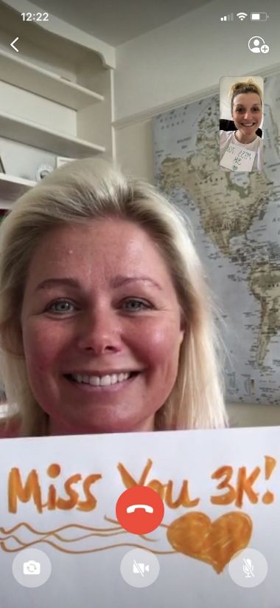
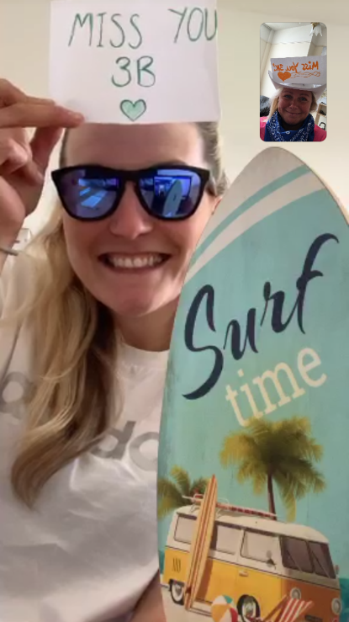
We miss you all so much!!! Keep going with the awesome home learning – we hope to see you soon

