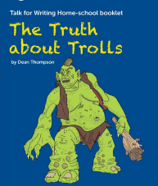
The Truth about Trolls Sequence Instructions

This sequence has been devised by the Talk 4 Writing scheme. It is a great scheme that really immerses the children into the story and allows them different opportunities to rehearse what they will write before they do any writing.
The booklet may look a little overwhelming so we have assigned activities for each day so that you can follow the sequence. Tick it off as you go along!

Monday 4th May 2020
- Share the story together
- Look at page 6. Go to the links about earthquakes and volcanoes. Make a poster of your new learning.
Tuesday 5th May 2020
- Share the story again
- Have a go at page 7. Look at the words in bold and see if you can jot down what you think they mean.

Wednesday 6th May 2020
- Have a go at the ‘grammar games’ on page 8. Who can use the most exciting adjectives in the game?

Thursday 7th May 2020
- Use page 10 ‘add on adverbs’ game. Then have a go at the challenge at the bottom of the page.

Friday 8th May 2020
- Go over the ‘add on adverbs’ game that you played yesterday and then use page 11 to make some sentences with these adverbs. Remember we are looking forward to seeing your beautiful handwriting!

