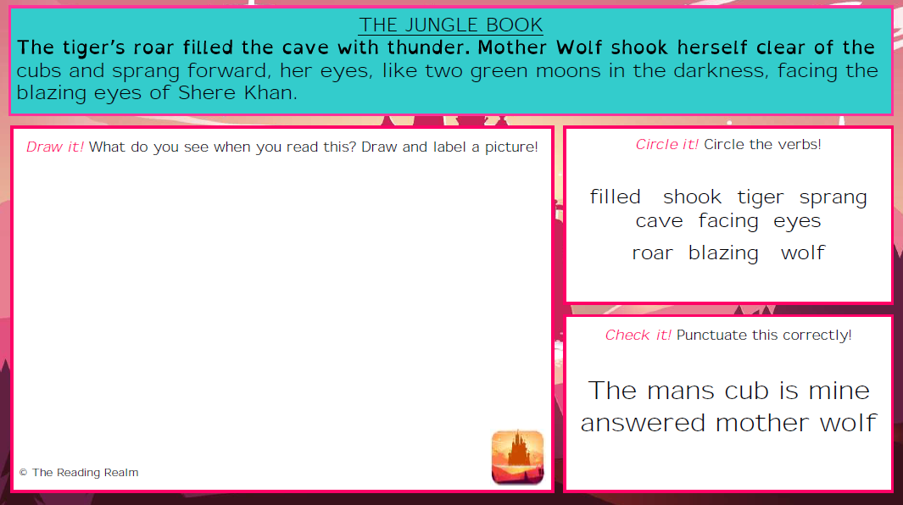
You could do this in paint or an editing app.
Underline it! Underline the verbs
Filled shook tiger sprang
Cave facing eyes
Roar blazing wolf
The mans cub is mine answered mother wolf

