https://www.bbc.co.uk/programmes/b03g6vs6

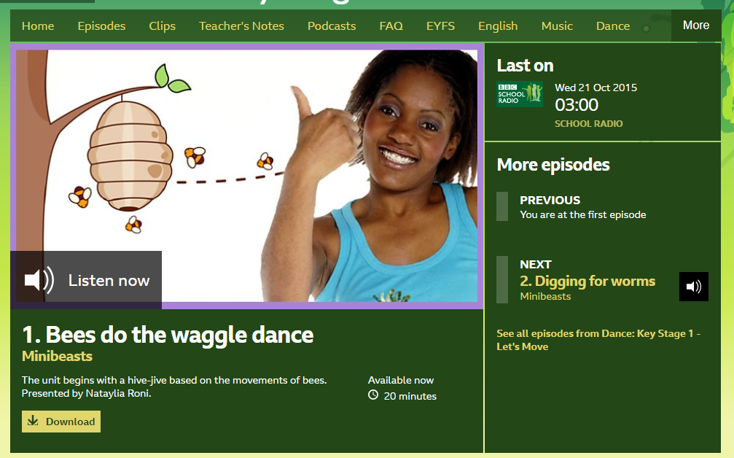
You may need to download the programme rather than login

