Apollo was the Greek god of knowledge. He has found these words in the story and wants to know if you can sort them out. First put these words into alphabetical order:
powerful condition curiosity unbearable trembling rubies gown spite fled infested sobbed pleaded
released hope

Now match the word to its meaning in the story – the first one has been done for you.
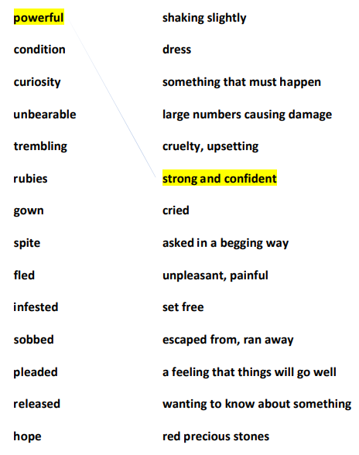

Well done! Now that you have matched the words to their meanings. Take each word and put it into a new sentence. (Don’t forget to start with a capital letter and finish with a full stop.)


