Position and direction - Day 1

Activity 1
Use the following instructions to guide someone at your house around your home or garden:
Forwards
Backwards
Left
Right

Activity 2
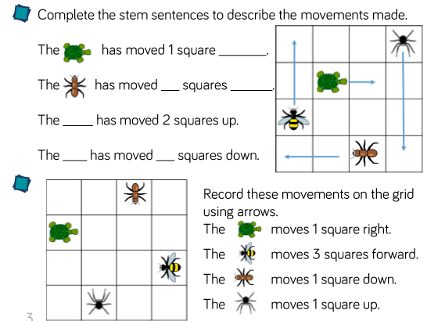

Activity 3


