Position and direction - Day 4

Activity 1
Possible questions to support this activity:
What is happening in the pattern?
What would the next shape look like?
How would you describe its position?
How can we work out the missing shape?

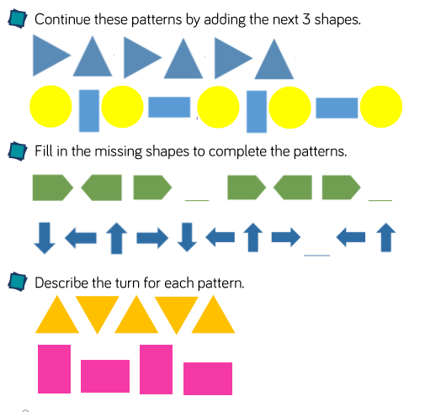

Activity 2


