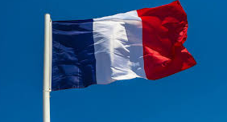
Focus: French- parts of the body

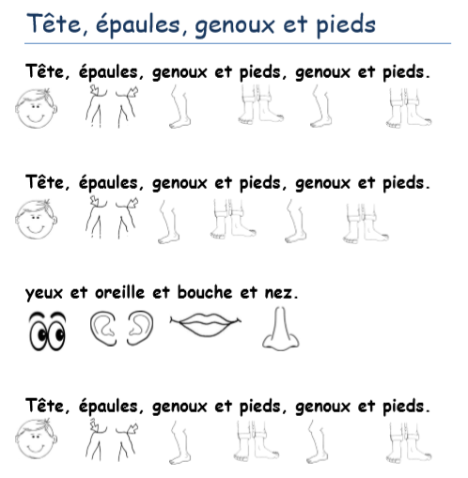
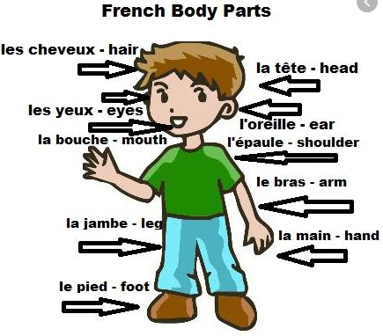
Can you remember the names of parts of the body? Have a look at the diagram below and practise the words you know. Your task is to label a teddy or toy with the parts of the body and, if you can, learn the song ‘Heads, shoulders, knees and toes’ in French. Can you teach someone in your family the parts of the body? Here is a link to the song: https://www.youtube.com/watch?v=0EFXCdryyRM

