A quadrilateral is a 2D shape with four sides. All the angles in a quadrilateral add up to 360°.
Find the missing lengths of each shape? # Can you find the missing angles?
*In your workbook you can record the title, date and answers.
.
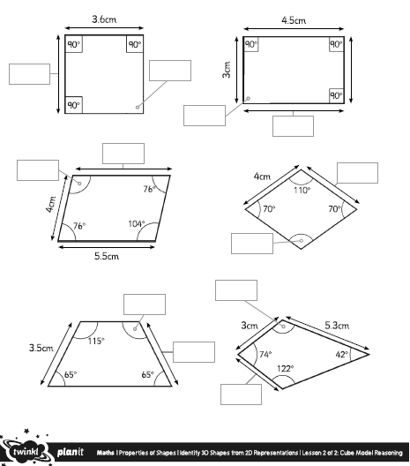
#f
#e
#d
#c
#b
#a
f
e
d
b
c
a



