Year 3 Home Learning-WB 15.06.20
Our key priorities for learning this week:
- Maths- Times table practice, shape work
- English- To write a report on a doorstep wildlife e.g. hedgehogs, ladybirds, butterflies, caterpillars etc….
- Reading- Read to an adult each day (must) + reading comprehension (optional).
  English-please complete every day:  Writing: To write a report on an animal of your choice (choose an animal you’d find in your garden). Please remember to include capital letters, full stops and lots of powerful adjectives to make your writing exciting.  Reading: reading 1:1 and reading comprehension  Words of the week:  castle, festival, famine, anguish, archaic |  | Maths-please complete every day:  Choose from…….  - Please complete a page a day on ultimate times table practice  - Times Tables Rockstars 20 minutes each day  - Time: It is important to know how to read a clock – Please keep rehearsing this skills as an ongoing things at home  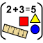  - Turns and Angles : Go through the Powerpoint on the week’s menu. Then have a go at the worksheets looking at turns and angles. We will be working on shape and space for the next few week’s so identifying directions like north, south etc will be a good starting point and rehearsing what a quarter / half a turn is.
Choose at least one activity per day from the list below

Science  Mini beasts & making a bug hotel  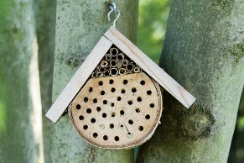    Collect dead wood/dry wood/a log/ sticks, tubes/ leaves etc and make a bug hotel ( a place for insects to be safe in your garden/ woodlands ). Hide it somewhere under a tree or a hedge or hang it up. We are looking forward to seeing these bug hotels please so photos if you can!! | Music  Charanga.    Use your login and follow the lesson. |  | PSHE    Nature Guide: How To Be a Good Citizen and Look After The Nature  Create a small booklet/poster or a postcard on how to look after our glorious wildlife and nature. What should you do and what should you not do? Think about 5 or 6 ideas.  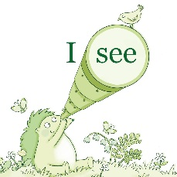
PE  It’s the Summer term so let’s practice for sports day as this is what we would be doing if we were in school.    Now lets practice our relay races. Have a go at using a water bottle at home with siblings or your parents at setting up and having a go at a relay race (make sure you don’t drop your bottle – or you’d have to start again!) | Geography  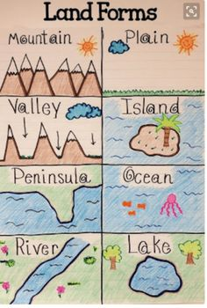  Investigate landforms and create a fun A3 poster as above with the following : mountain, plain, valley, island, peninsula, river, lake |  | Art & Design  We would like you to continue with your design on making a stone age scene from a shoe box.  We cannot wait to see your final design!  Optionally, any wildlife sketches of butterflies, caterpillars, hedgehogs, dragonflies etc would be fantastic!  
We miss you all so much!!!
Miss Brown, Mrs Keilty & Mrs Cameron
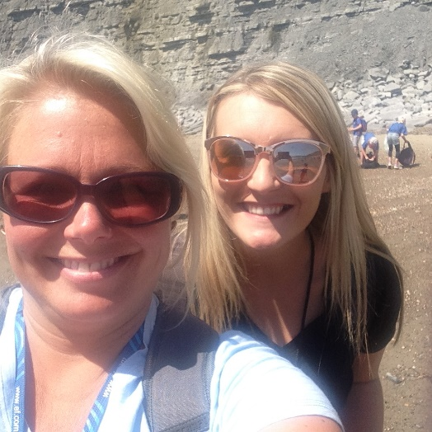
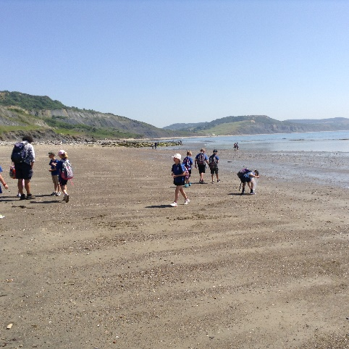

Miss Brown and Mrs Keilty are wishing we were on a school trip to Lyme Regis with you all

