Week beginning 11th May 2020
Science home learning: Sound
Read ‘How Sound is made’ to remind yourself about sound.
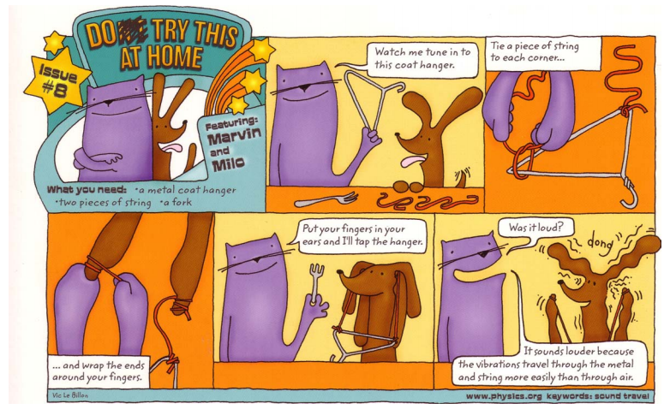
Try one or both of the activities below. Take some photos!
Making Music with Water
Have you ever tried making music with glasses or bottles filled with water? I bet your favourite band hasn't. Experiment with your own special sounds by turning glasses of water into instruments, make some cool music and find out how it works.
What you'll need:
- 5 or more drinking glasses or glass bottles
- Water
- Wooden stick such as a pencil
Instructions:
- Line the glasses up next to each other and fill them with different amounts of water. The first should have just a little water while the last should almost full, the ones in between should have slightly more than the last.
- Hit the glass with the least amount of water and observe the sound, then hit the glass with the most water, which makes the higher sound?
- Hit the other glasses and see what noise they make, see if you can get a tune going by hitting the glasses in a certain order.
What's happening?
Each of the glasses will have a different tone when hit with the pencil, the glass with the most water will have the lowest tone while the glass with the least water will have the highest. Small vibrations are made when you hit the glass, this creates sound waves which travel through the water. More water means slower vibrations and a deeper tone.

