Week beginning 11th May 2020
Focus: French numbers
Can you remember how to count in French to 10? Look at the words below and practise saying them in. This link will show you the numbers and if you click on them you can hear how to pronounce them.
https://www.french-games.net/frenchlessons?topic=Numbers%20-%201%20to%2010&level=primary
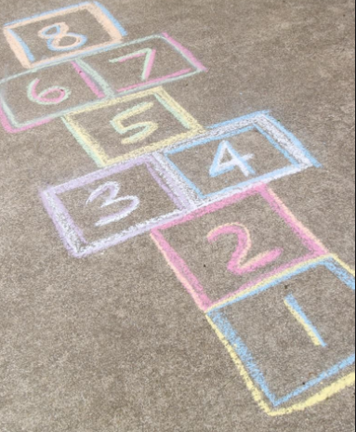
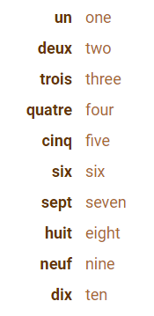

Watch this game of Hopscotch being played https://www.bbc.co.uk/bitesize/clips/zcwrkqt
When you next go outside, try playing hopscotch in French.
If you can’t do that, try counting to ten every time you walk up some stairs or steps or can you count as you do some star jumps?

Challenge: Can you count backwards from 10?


