Brixington Primary Academy
Even though we are not in school at the moment, all of our school policies still apply to pupils. It is incredibly important that we safeguard each child and ensure they are following e-safety guidelines.

Parental support
It is important that, as parents and carers, we understand how to set filters, have conversations about who children are talking to and what they are looking at. Below is a link to some information that may support this:
https://www.vodafone.co.uk/mobile/digital-parenting
https://www.saferinternet.org.uk/our-helplines
https://primarysite-prod-sorted.s3.amazonaws.com/first-federation-redesign/UploadedDocument/b877f577488d4c638d9b3fa64e0f5601/fft-pupils-e-safety-policy-june-2019.pdf First Federation E-safety policy

Cyber-bullying
If you believe your child is being cyber-bullied whilst off school, please inform your child’s class teacher, who will report it to the Safeguarding team.
You can report cyber-bullying remotely through CEOP there is also lots of information on here to support online safety.
https://www.ceop.police.uk/safety-centre/

Website
Please find on our website some useful guides to support E safety. In these unprecedented times, we must keep our children safe online. The internet and social media are going to be very important for keeping in touch but this must be done safely.

Advice for Children
Whilst you are learning from home, it is incredibly important that you have access to the internet to complete the tasks your teacher has set and to keep in touch with your friends.
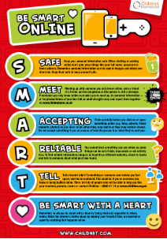
Remember to Be SMART online.
- Stay safe
- Only speak to people you know
- Tell an adult if someone is unkind to you
- Send only KIND words to your friends.
If you are unsure if a message is unkind, please show an adult in your house. We have recently had Childline in school; they made it clear to everybody what is OK and what is not. Please remember the number
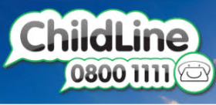

https://www.childline.org.uk/

Stay safe Keep in touch Be Kind

