Geography Homework Project
Island of The United Kingdom

Make a colourful and informative poster based on the geography of the British Isles.
Things to include:
- A map
- Information about towns, cities and rivers and mountains
- Flags of the countries
- Numerical data eg. highest mountain, longest river, biggest city etc….
- Images of the natural beauty

Use any form of a presentation: PowerPoint, poster, booklet ….
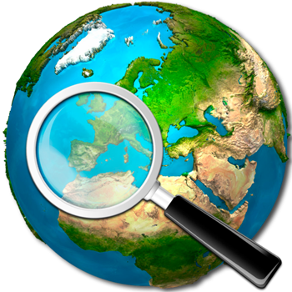Year 3 Teaching Team

