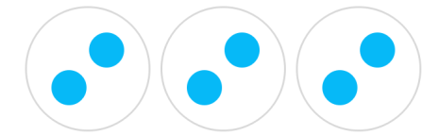
There are ____ equal groups with ____ in each group.


There are ____ equal groups with ____ in each group.


There are ____ equal groups with ____ in each group.

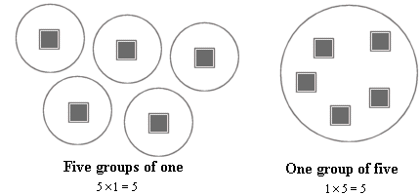
There are ____ equal groups with ____ in each group.
I have two ____.


There are ____ equal groups with ____ in each group.
I have three ____.
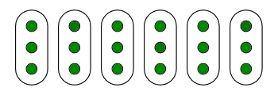
There are ____ equal groups with ____ in each group.
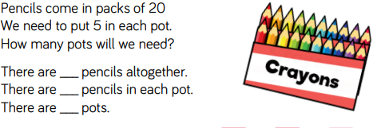
I have six ____.

