Tuesday
Diving for Depth

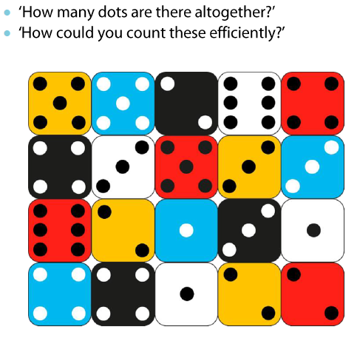

Think about using number bonds to 10….

