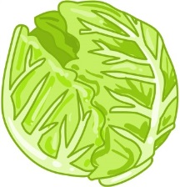
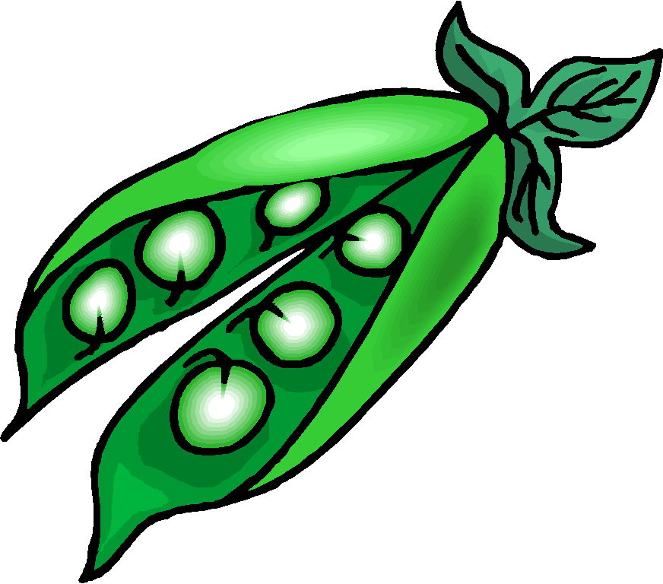
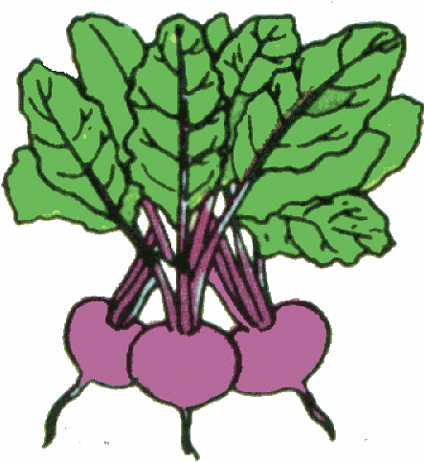

Oliver’s vegetables

- Oliver had 23 carrots but he liked them so much he ate 9 of them. How many were left?

- His Grandad planted some sweetcorn. He put 12 seeds in one pot and then 7 seeds in a different pot. How many sweetcorn seeds did he plant?

- Oliver planted 27 radishes but rabbits got into the garden and ate 5 of them. How many are left?

- Oliver and his granddad went to the garden centre. They bought some pots for 14p and some seeds for 8p. How much money did they spend?

- Oliver made a salad. He put in 13 tomatoes and 7 peas. How many vegetables are there altogether in the salad?

- His granddad likes spinach so planted 26 of them. It rained so much that 8 of them didn’t grow. How many did grow?

- On Monday Oliver picked 2 potatoes. On Wednesday he picked 14 potatoes. On Friday he picked 3 potatoes. How many potatoes did he pick altogether?

