Science home learning week beginning 29th June 2020
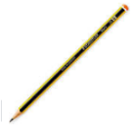
Focus: To explore and name a variety of living things in our local environment
You will need a piece of paper and a pencil.

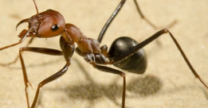
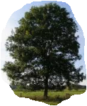
With an adult, go for a walk around your garden or your local environment. Look for all the living things you can see. Can you see insects, birds, trees, flowers? Can you name any of them? If you want to, take some photos of the living things.

Record all the different types of living things you can see and list them down the side of your paper.

Repeat your walk but this time keep a tally of how many times you see each living thing. At the end of your walk, look at which living thing you saw the most and which you saw the least? Were there any living things you didn’t know?

Draw or make a collage of some of the things you found.

