05.01.20 – afternoon History lesson
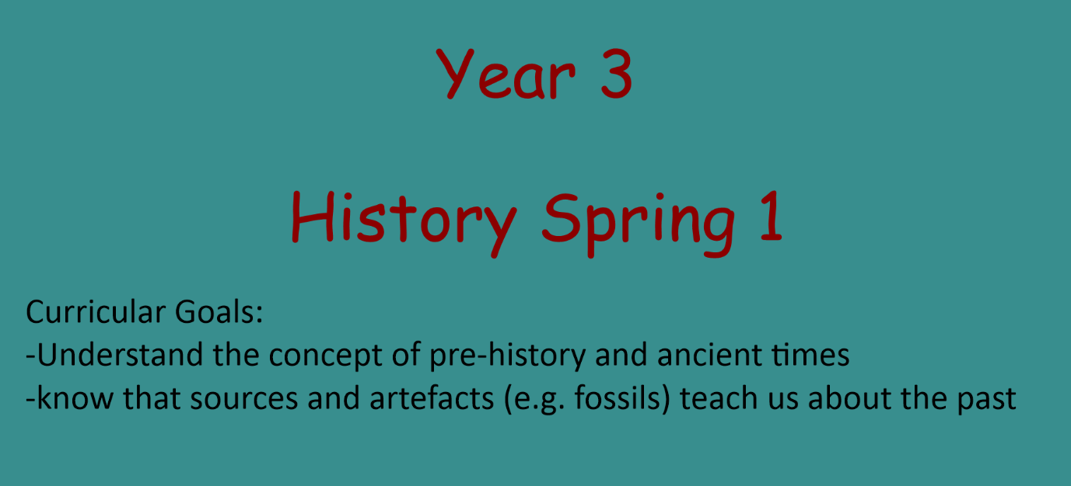
Below are screenshots taken from our planned slides for the first History lesson in our sequence. Read through each of the slides and follow the tasks / links that we are asking you.
1.

In History this half term we are looking at Pre-Historic times. It is so important that we know 2 main things by the end of this half term: understand the concept of pre-history and ancient times and know that fossils teach us about the past. We will be doing lots of different activities in the coming weeks to cover this topic but for now enjoy learning all about a very important lady.
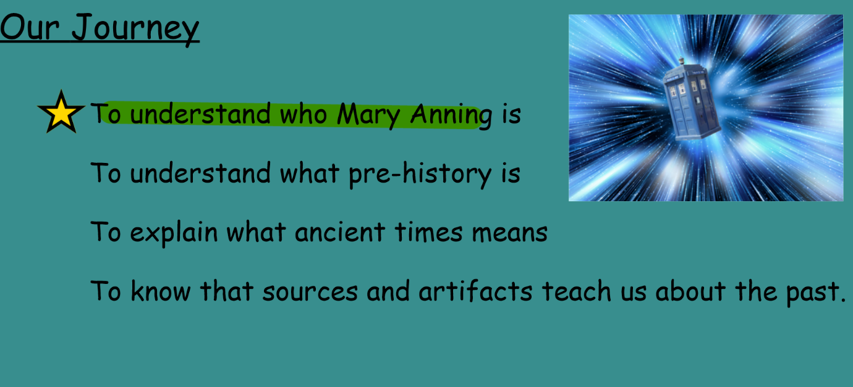
2.

This is our journey for the next 6 weeks and some of the things we will be covering so that you can know where we are going with the learning.

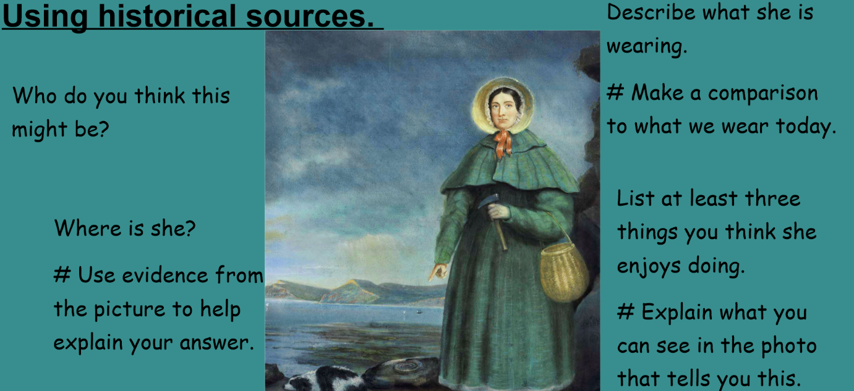
3.

Answer questions above on paper.

4.
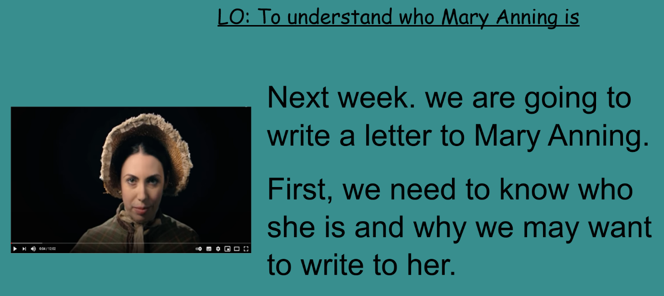

The lady in the picture above was Mary Anning! She is a very key historical figure when talking about fossils and we are going to find out all about why she was important and what she did. We would like you to watch this clip on YouTube all about the life of Mary Anning and hopefully afterwards you learn new things that you didn’t know about her.
https://www.youtube.com/watch?v=qNOh-85_Dmc (the life of Mary Anning)
https://www.bbc.co.uk/bitesize/topics/zd8fv9q/articles/zf6vb82 - use this link to find out and explore even more about who Mary Anning is.
Your children are welcome to explore some different websites (checked by parents that they are appropriate) and they can research even more about who Mary Anning is.

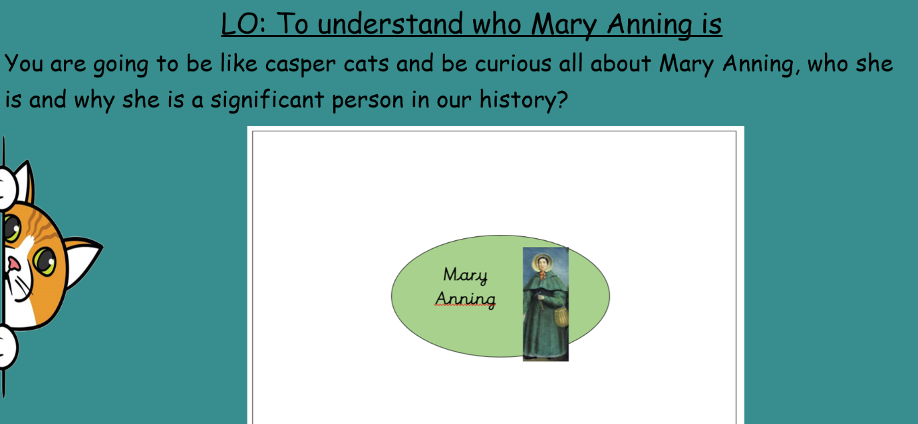
5.

We would like you now to record everything that you have found out using our fact page (on website if you want to use ours) or if not get yourself a piece of paper and design a fact file/fact page all about Mary Anning. We would like you to ensure the page is full of facts and your head is full of knowledge about who this lady is and why she Is important. You could even record yourself reading some of the facts you know off by heart or send in a picture/email your final piece of work designed all about Mary Anning and answer the question: why is Mary Anning so important when talking about fossils and the pre-historic period (DON’T FORGET BEAUTIFUL HANDWRITING PLEASE!)

