This week you have been focussing on the ey sound. Today log in to Phonics Play and complete these activities;
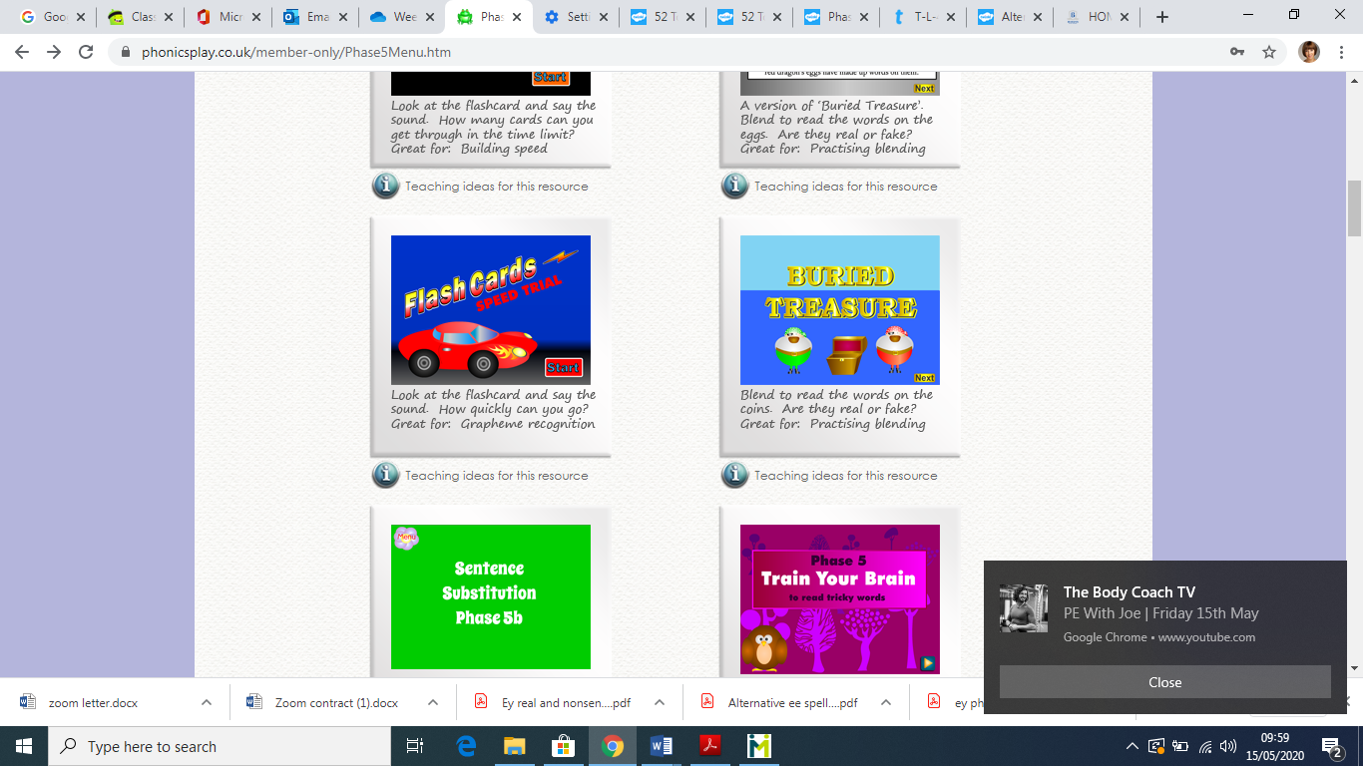
- Phase 5 – Flash cards – Speed trial

- Phase 5 – Tricky words Trucks
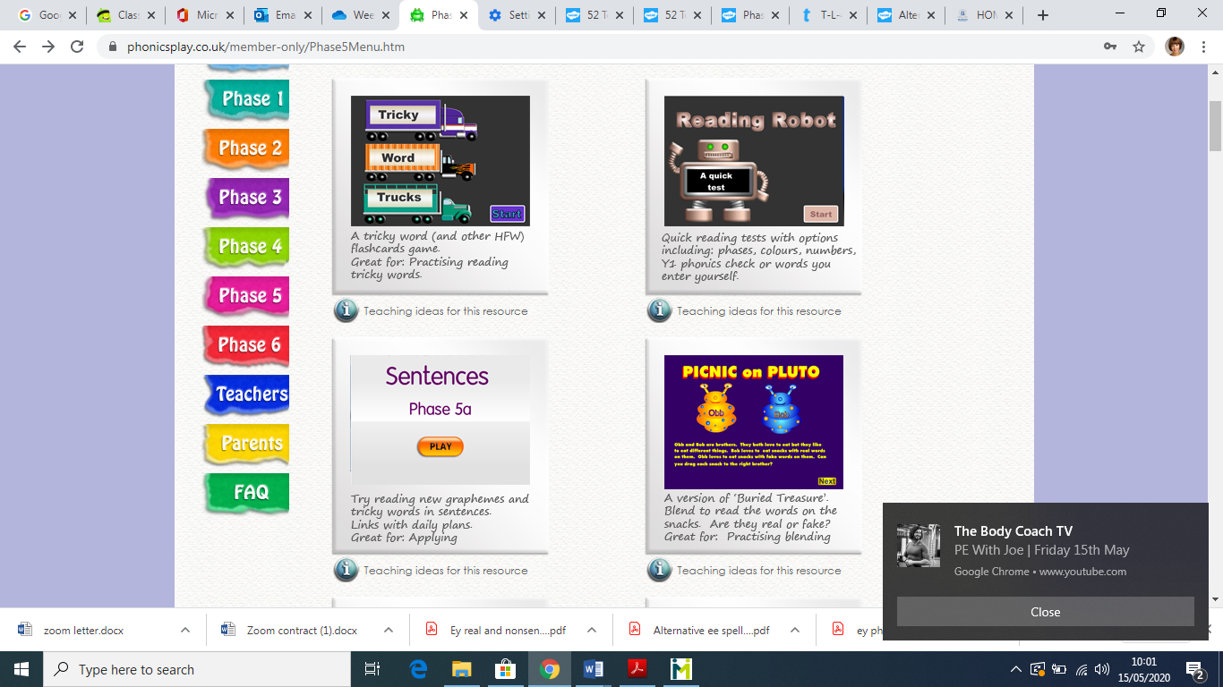

- Phase 5 – Picnic on Pluto with Obb and Bob selecting the ey sound before starting.

- Phase 5 – Buried treasure selecting the ey sound before starting.

- Phase 5a – Sentences, selecting ey sound before starting.

