

Look at the powerpoint ‘All about teeth and their functions’. Once you have read it or had someone read it to you, wash your hands then look at your teeth using a mirror. Do you recognise what type of teeth you have?

Now, feel the teeth you have in your mouth.
Can you feel your incisors? 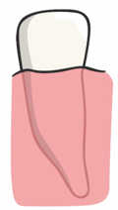

Can you feel your canines? 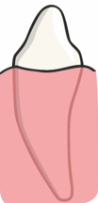

Can you feel your molars? 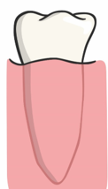

Create a poster instructing people how to look after their teeth. Remember to use your bossy (imperative) verbs!
EG: Brush your teeth twice a day.

‘Brush’ is a bossy verb.

Don’t forget to do lots of lovely illustrations.

Teeth

