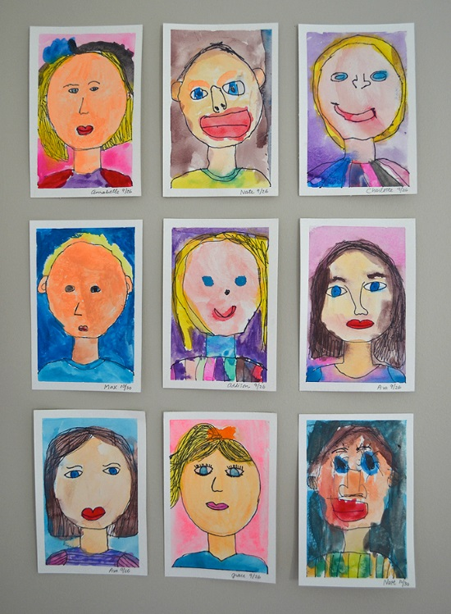 ART Activity
We are missing you so much so we would love to see some of your self-portraits!
So, a creative task for this week is to create your own self-portrait. Send us a picture if you can please!
Here’s a helpful clip for the outline if you need some help.
https://www.youtube.com/watch?v=lmUrxx0hdv4

