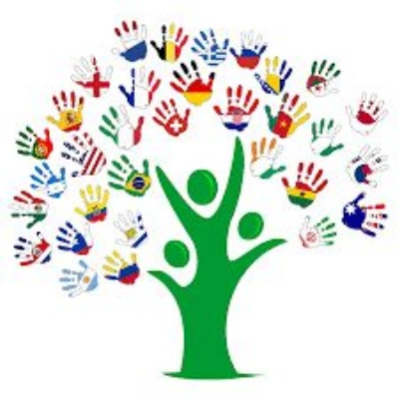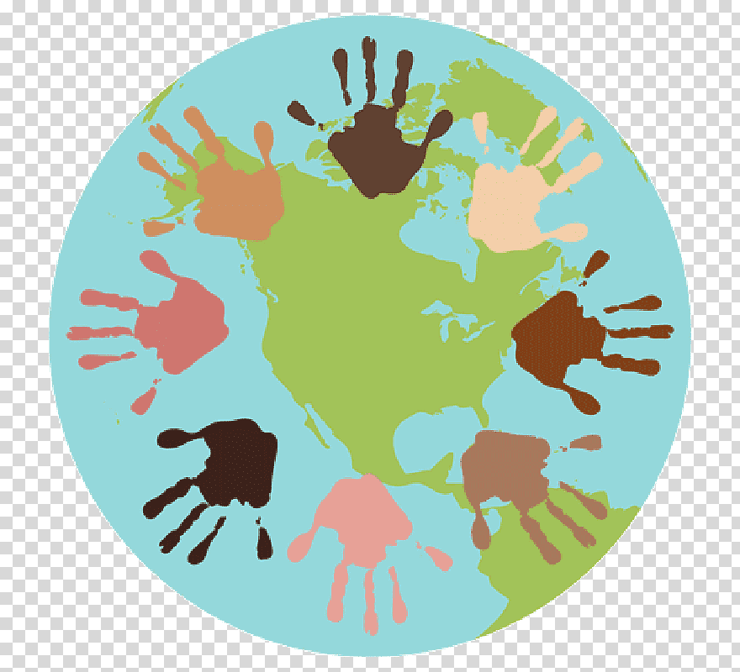

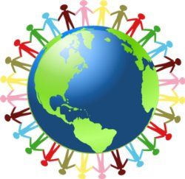

World Culture Day
21st May 2020

Activity:
Learn about another/ country in the world. Find out about their flag, culture, food, religion, population, capital city, landmarks, language etc.
You can make a presentation of your own choice eg PowerPoint, paper leaflet, a booklet, a poster or anything creative really!
We know you love geography so we are looking forward to learning with you!
Don’t forget to pick a country of your own interest and choice! The more exotic the better!!

