How Escalators Work
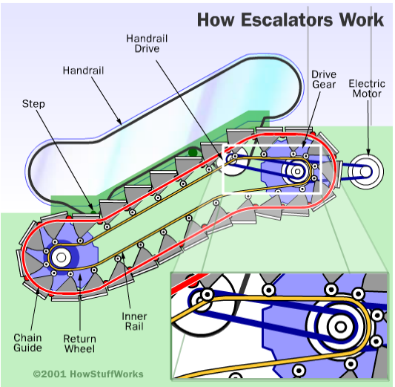
Escalators are easy to use. However, their design is far from simple. This article will explain how an escalator works and how they are more complex than a simple conveyer belt.

Escalators do not move a flat surface, as in a conveyer belt. Instead, the chain loops move a series of steps. Therefore, as the chains move, the steps always stay level. At the top and bottom of the escalator, the steps collapse on each other, creating a flat platform. Consequently, this makes it easier to get on and off the escalator. In the diagram, the internal workings of an escalator can be seen.

Each step in the escalator has two sets of wheels, which roll along two separate tracks. The upper set (the wheels near the top of the step) are connected to the rotating chains. As a result, they are pulled by the drive gear at the top of the escalator. Meanwhile, the other set of wheels simply glide along its track, following behind the first set.

CLICK for animated version of diagram

Unit 2 Day 1

How Escalators Work – Answers – Cause Contrast
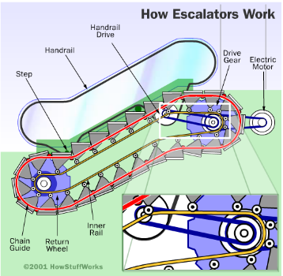
Escalators are easy to use. However, their design is far from simple. This article will explain how an escalator works and how they are more complex than a simple conveyer belt.

Escalators do not move a flat surface, as in a conveyer belt. Instead, the chain loops move a series of steps. Therefore, as the chains move, the steps always stay level. At the top and bottom of the escalator, the steps collapse on each other, creating a flat platform. Consequently, this makes it easier to get on and off the escalator. In the diagram, the internal workings of an escalator can be seen.

Each step in the escalator has two sets of wheels, which roll along two separate tracks. The upper set (the wheels near the top of the step) are connected to the rotating chains. As a result, they are pulled by the drive gear at the top of the escalator. Meanwhile, the other set of wheels simply glide along its track, following behind the first set.

CLICK for animated version of diagram

Unit 2 Day 1

How Alexa works

Amazon have built a natural-language processing system that is easy to interact with. It can be used by the whole family.

It uses a wake word: “Alexa,”. This can be changed to “Echo,” “Amazon,” or “Computer.”

Once the wake word is said, the microphone is switched on. It transmits what is said to cloud computers for quick analysis.

Users ask questions which are then processed by the computers. The Echo will answer the question in a female voice.

The Echo does not only answer questions. It can play music, tell jokes and provide an alarm.

The Echo can be linked to other devices. It can be used to switch on lights, control the heating and even lock the front door.
Contrasts
however
meanwhile
nevertheless
instead
yet
Causes
therefore
thus
consequently
as a result
- Read this explanation of how the virtual assistant, Alexa, works.
- Link each pair of sentences using adverbs for cause or contrast.
- Rewrite/edit the sentences, adding adverbs and punctuating as necessary.

Example
Amazon built a natural-language processing system that is easy to interact with. It can, therefore, be used by the whole family. or
Amazon built a natural-language processing system that is easy to interact with. It can be used by the whole family therefore. or
Amazon built a natural-language processing system that is easy to interact with. Therefore, it can be used by the whole family.

Unit 2 Day

