Monday 13th July 2020

★ Story map Challenge
Here’s a story map. Can you work out what the story is from looking at the map?
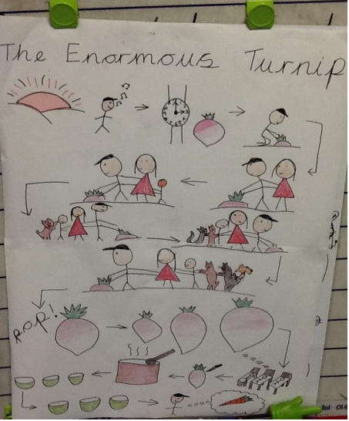

Here’s a version of the story for you to listen to. https://www.youtube.com/watch?v=mGw5yTOPTSQ
Can you see which bits of the story have been included in the map?

Your challenge is to turn the first verse of Mr Quangle Wangle’s Hat poem into a story map. Read the verse slowly and draw a picture for each new idea until you have a map of the whole verse! If you want, you could continue and do the whole poem. You can use this page or draw on a bigger piece of paper if you have one at home.
The Quangle Wangle’s Hat
On the top of the Crumpetty Tree
The Quangle Wangle sat,
But his face you could not see,
On account of his Beaver Hat.
For his Hat was a hundred and two feet wide,
With ribbons and bibbons on every side
And bells, and buttons, and loops, and lace,
So that nobody ever could see the face
Of the Quangle Wangle Quee.

