Tuesday 14th July 2020

★ Description Challenge
Here’s the last but one verse again. There’s a lot of creatures in it.
And the Golden Grouse came there,
And the Pobble who has no toes,
And the small Olympian bear,
And the Dong with a luminous nose.
And the Blue Baboon, who played the flute,
And the Orient Calf from the Land of Tute,
And the Attery Squash, and the Bisky Bat,
All came and built on the lovely Hat
Of the Quangle Wangle Quee.
Here’s a description of one of them:
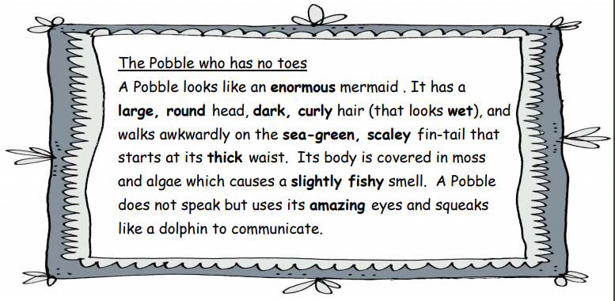

2. All the adjectives, the words that describe things, have been highlighted. Read it through and circle the adjectives you like best.

3. Now you are going to imagine what two other characters from The Quangle Wangle’s Hat, Dong and Attery Squash, are like. Think about what they look like and other things like what they smell or sound like. Draw your ideas in the boxes

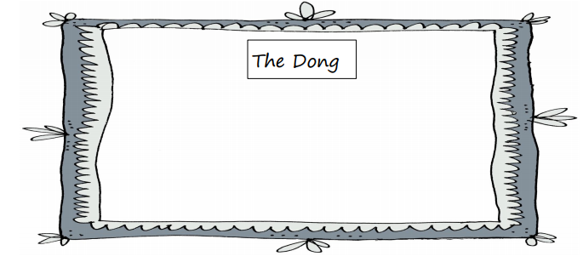

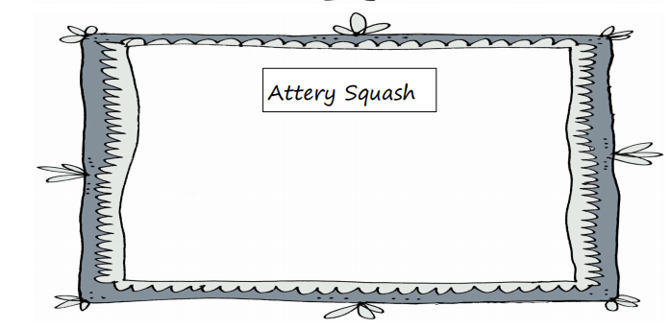

Use the space below to write your two descriptions or write on some paper you have at home.


