Thursday 16th July 2020

Now turn your ideas from yesterday into a simile poem like the Pobble. Use this sheet to write your poem. Don’t forget to start with the title of your poem.
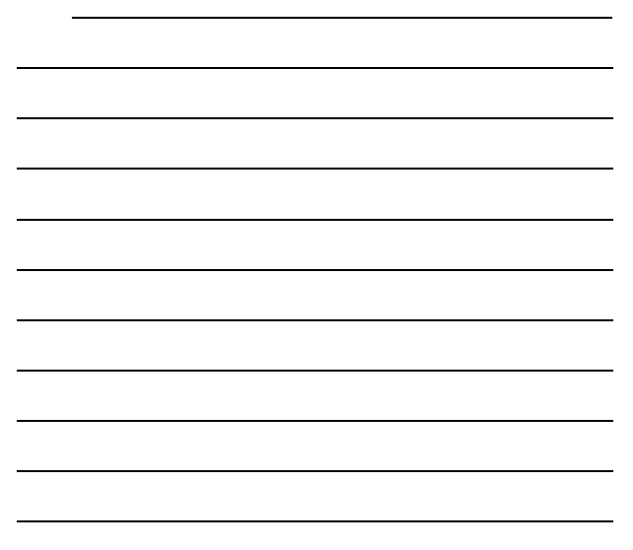
Don’t forget to:
✓ Read your poem out loud to check it sounds right.
✓ Check you’ve started each line with a capital letter and ended with a full stop.
✓ Check your spelling.

I would rate my journey through this unit (tick hot or cold):
★If you tick near the top of the red thermometer, that means you really liked it.
★If you tick near the bottom of the blue thermometer, that means you really did not like it.


