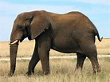
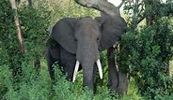
African Elephants

African elephants are the world’s largest land mammal. Here are some interesting facts about them…

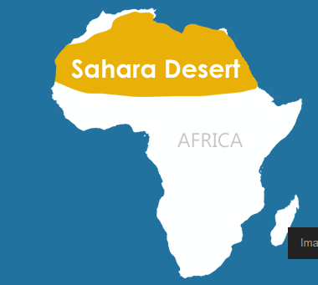
Where do they live?
African elephants live in Sub-Saharan Africa.
This is south of the Sahara Desert.

How are Elephants Suited to Their Habitat?
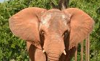
They have many interesting features including giant ears, long tusks, and a huge trunk.
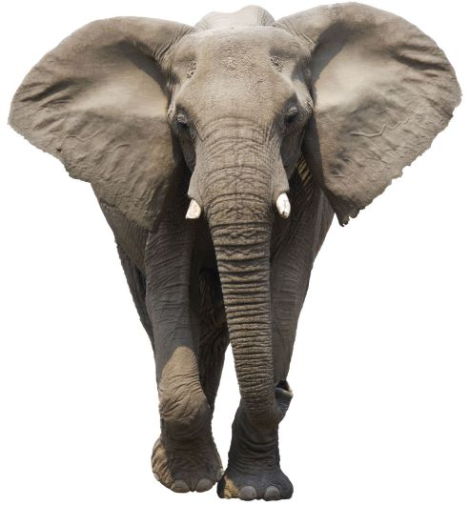
Elephants flap their giant ears to cool off.

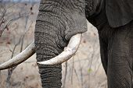
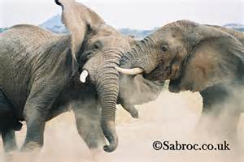
Elephants use their tusks to dig or scrape the bark off trees. Sometimes they use them to fight.
Their tusks can be up to 10 feet long.

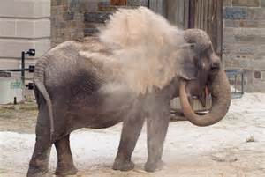
Did you know that African elephants have two things which are like fingers on the end of their trunk? This helps them to pick up things.
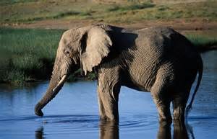
An elephant drinking

An elephant is spraying itself with sand to cool down.

What do Elephants Eat and Drink?


Elephants are herbivores as they eat fruit, bark, plants, grass and roots. They can eat up to 400 pounds of food each day. This is about the same as the weight of 3 people! African elephants dig holes to find water underground. They drink about 30 gallons of water a day = 136 bottles!

