08.02.22

LO: To solve problems using the 2, 5 and 10 times tables.
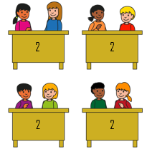
2.

______ X _______ = _______

______ X _______ = _______

______ X _______ = _______

______ X _______ = _______



3.
4.

______ X _______ = _______

______ X _______ = _______

______ X _______ = _______

______ X _______ = _______

Sort the expressions into the table below.
7 X 2 5 X 6 9 X 10 4 X 2 5 X 5

3 X 2 10 X 9 4 X 10 8 X 2 1 X 10 0 X 2

2 times table | 5 times table | 10 times table

