08.02.22
LO: To solve problems using the 2, 5 and 10 times tables.

4 X 2 = ______

2 X 4 = ______


2 X 3 = ______

3 X 2 = ______


5 X 2 = ______

2 X 5 = ______


2 X 6 = ______

6 X 2 = ______

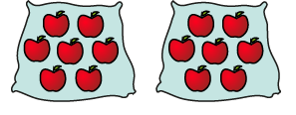
2 X 7 = ______

7 X 2 = ______

