09.02.22
LO: To solve problems using the 2, 5 and 10 times tables.
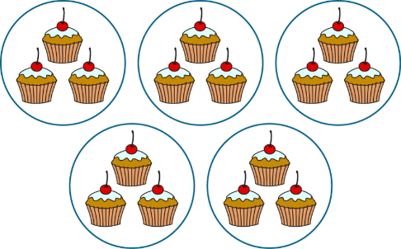

1.
2.

_______ X _______ = ______

_______ X _______ = ______
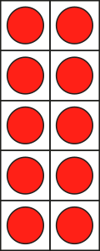

3.
4.

_______ X _______ = ______

_______ X _______ = ______

In your book, can you draw two arrays for each expressions?
1. 4 X 2 2. 7 X 5 3. 10 X 4 4. 5 X 3 5. 2 X 8

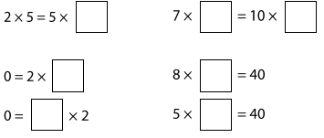
Fill in the missing numbers;

<, > or =?


