09.02.22
LO: To solve problems using the 2, 5 and 10 times tables.
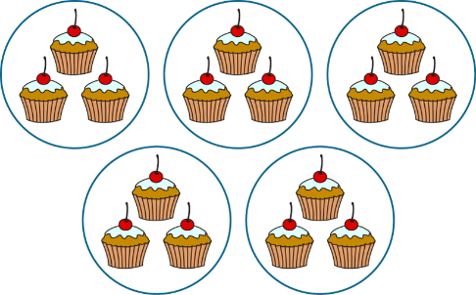

1.
2.

_______ X _______

_______ X _______


3.
4.

_______ X _______
_______ X _______

Use counters to answer the following questions;
1. 6 X 2 = ______

2. 10 X 3 = ______

3. 5 X 5 = ______

4. 2 X 8 = ______

5. 9 X 5 = _____

