10.02.22

LO: To recognise patterns of commutativity.
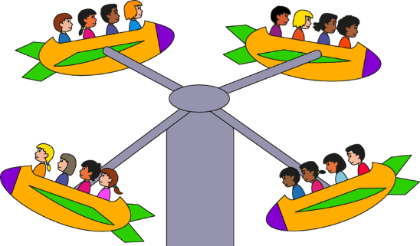

________ X _________
________ X _________


________ X _________
________ X _________


________ X _________
________ X _________

________ X _________
________ X _________

In your book, draw an array to represent the following equations;
3 X 6 = 18 7 X 4 = 28 8 X 9 = 72 3 X 3 = 9
Challenge: Can you show me the arrays in a different way?

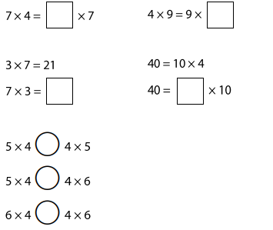
Fill in the missing numbers;

