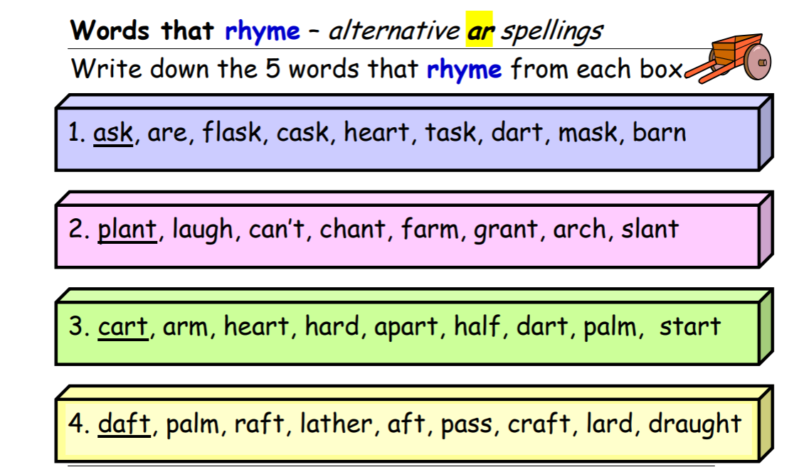

Now write some sentences with different ‘ar ‘ words in!

